**Subject:** Your Playa Viva dossier is ready | The Wynn Effect

**Body:**

Hello [Lead Name],

Thank you for your interest in Playa Viva. Here is the personalised dossier you requested about this unique opportunity on Al Marjan Island.

In this analysis, you will discover in detail the impact of the "Wynn Effect" and the true potential the area offers.

*(Here you would insert the main download button, linking to the dossier)*

**[ Button: Download my Dossier ]**

Your Next Step: Let's Talk for 15 Minutes

Once you have reviewed the data, the logical next step is a private, no-obligation 15-minute consultation.

In this call, we will analyse how this investment aligns with your personal goals and answer your direct questions.

For your convenience, you can **book a time that works best for you directly on my calendar**. There's no need to reply to this email, although I am also happy to answer any questions you may have here.

*(Here you would insert the secondary button, linking to Michael's HubSpot Meetings calendar)*

**[ Button: Schedule my 15-Minute Consultation ]**

I look forward to hearing from you.

Best regards,

**Michael McMullen**, Official Agent at Uniestate UK **michael@uniestaste.co.uk**

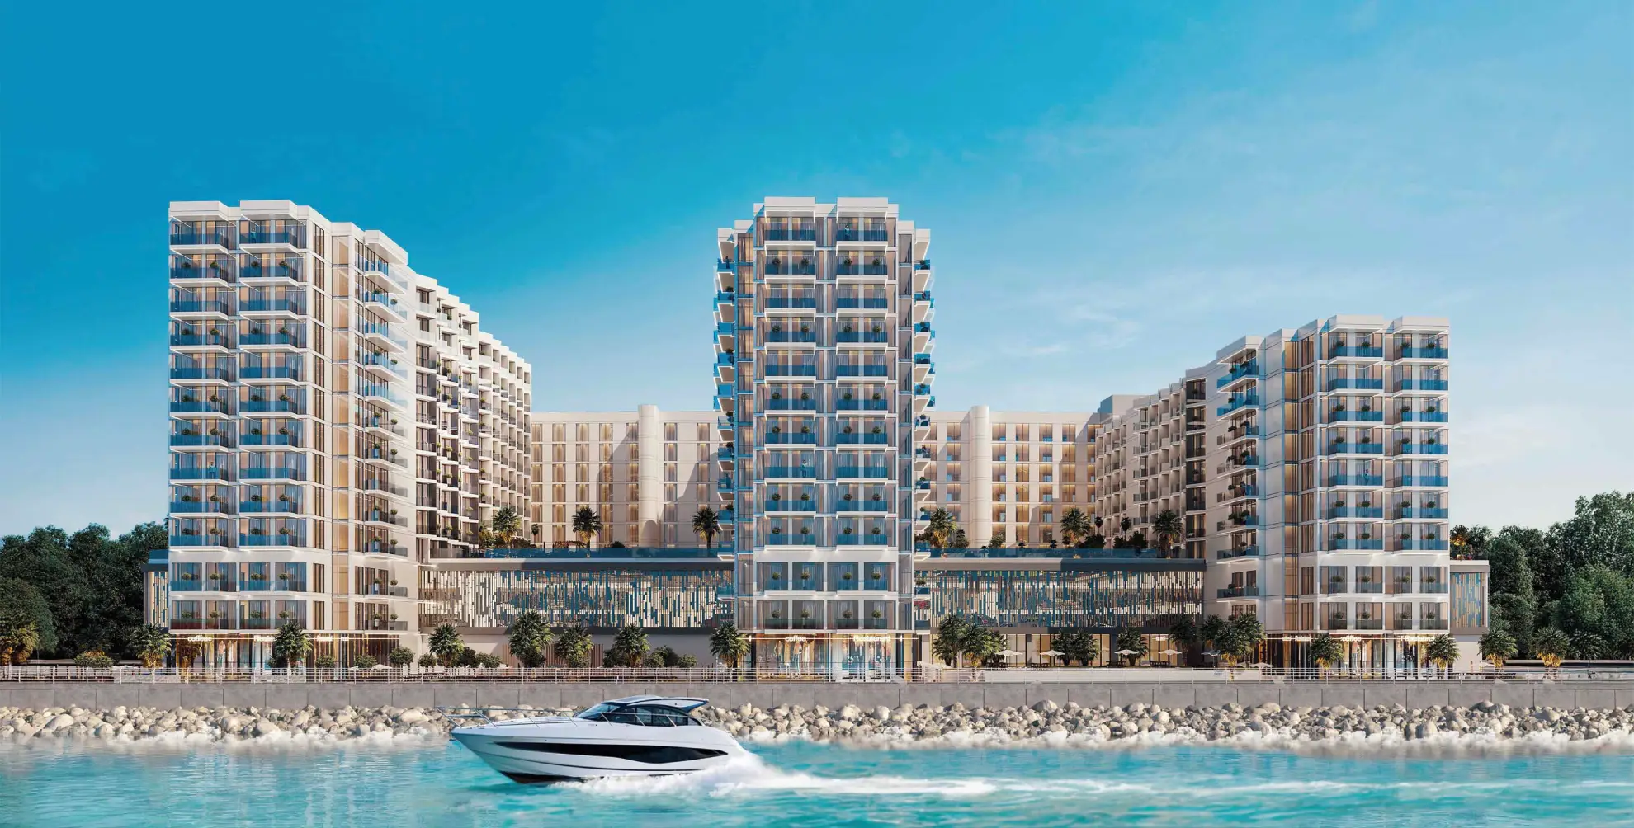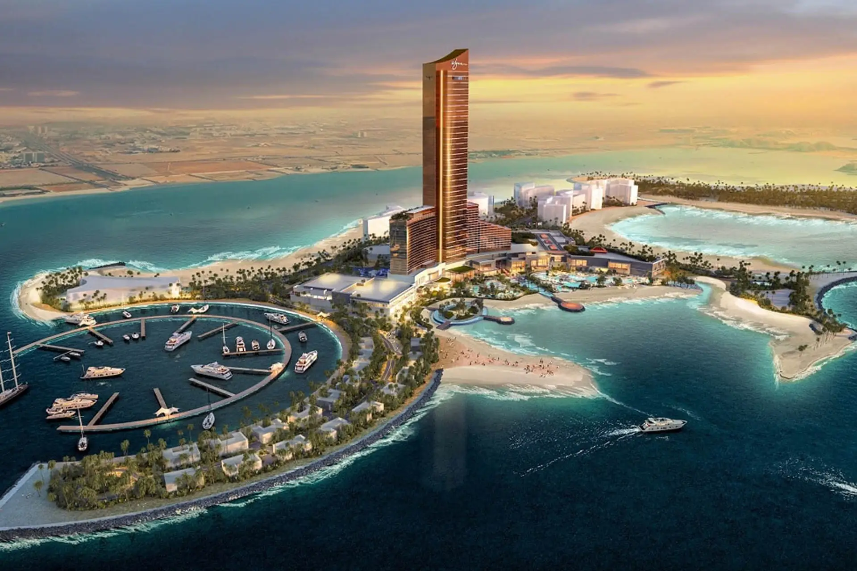

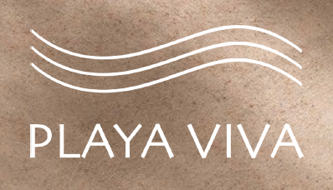

P.S. If the download button doesn't work, copy and paste this link into your browser: [Direct link to the PDF dossier]

P.S.1. I have availability this Thursday and Friday afternoon (Dubai time). If you'd prefer to talk sooner, choose your time slot here.P.S.2. If the book appointment button doesn't work, here's the link: [Direct link to HubSpot Meetings calendar]